Traditional Christian (Dionysian) Apologists love to parade the thousands of Church denominations that litter the neighborhoods and countrysides of the United States. They will demand we explain how all of these Churches came to be if the Bible is perspicuous(easy to understand) as the Protestant Reformation maintained. First, did you know the Catholic Church created most of these denominations? Second, did you know that many contradictory Churches exist from the early centuries of Christianity that all champion the same extra-scriptural tradition? The Gnostic, the Oriental Orthodox, the Eastern Orthodox, the Roman Catholic, the Arian and the Nestorian all claim the same tradition and Apostolic succession. Truth be told the Gnostics have the best case but I digress. In order to be a member of any of these ancient communions private judgment must be exercised as these six groups differ but claim the same tradition. The Dionysian metric of submission to Church authority only works if no private judgment is possible and there is only one Dionysian Church. But that isn’t the case is it? The vast majority of the denominational divisions, especially in the West, among non-Catholics is Evangelical Anabaptism, not Protestantism. The Anabaptist movement was created by the Jesuits. John Calvin, Institutes, Book 3, Chap. 3, sec. 2,

“But there is no semblance of reason in the absurd procedure of those who, that they may begin with repentance, prescribe to their neophytes certain days during which they are to exercise themselves in repentance, and after these are elapsed, admit them to communion in Gospel grace. I allude to great numbers of Anabaptists, those of them especially who plume themselves on being spiritual, and their associates the Jesuits, and others of the same stamp. Such are the fruits which their giddy spirit produces, that repentance, which in every Christian man lasts as long as life, is with them completed in a few short days.”

The Socinian movement was Anabapist as we see from The Racovian Catechism, Chapter 3. The Socinian movement was created by a Jesuit Priest named Dominicio Lopez. We read in the Encyclopedia Britannica, 11th edition, Vol. 25, page 322, speaking of Fausto Sozzini,

“His reputation as a thinker must rest upon (1) his De auctoritate s. scripturae (1570) and (2) his De Jesu Christo servatore (1578). The former was published (Seville, 1588) by Lopez, a Jesuit, who claimed it as his own…”

An offshoot of the Socinian movement was what is now known as the Hebrew Roots movement (another Anabaptist movement). It was created by a student of the Socinians named Martin Seidelius. The entire history of this Jesuit plot can be read in the preface of John Owen’s masterpiece Vindiciae Evangelicae. The Evangelical Anabaptist movement was progressed into an international fame and American foreign policy by Jesuit Priests Francisco Ribera and Manuel Lacunza in their development of Futurist Eschatology, which of course the Hebrew Roots movement believes as well.

The Arminian controversy within Protestantism during the 17th-18th centuries was also created by the Jesuits. During the trials of William Laud and Charles I, it was shown that Laud had correspondence with the Jesuit Proctor in Brussels, most likely Otho Zylius, and reported that the Arminian movement was their strongest weapon against the Reformation. (William Prynne, Hidden Works of Darkness, pg. 89)

We also see the root of the modern Charismatic and Pentecostal movements in the Arch-Jesuit himself, Ignatius Loyola, who was a champion of Charismaticism and the Jesuit created Anabaptist and Arminian movements. The Anabaptists were pioneers of this Charismatic movement with their Zwickau prophets. The remaining work was accomplished by Arminian Champion John Wesley. This history can be read in Donald Dayton’s Theological Roots of Pentecostalism.

The Protestant movement, by definition, means you Protest the Roman Papacy as the Antichrist. This is the Eschatology of Historicism. Protestant denominations have recently been corrupted away from traditional Historicism by the Preterist Eschatology of one Jesuit Priest by the name of Luis del Alcázar.

In my A Timeline of Jesuit Intrigue, pages 58-59 et al., I demonstrate how the Jesuits created modern Freemasonry; the order itself being an extension of ancient Catholic Knighthoods and the Catholic Templars. (See Freemasonry Demystified - Full Documentary by Veritas__Aequitas) The Mormon religion was created by Freemasons Joseph Smith and Brigham Young. It was also an admitted extension of the Jesuit created Methodist Church community Joseph Smith was raised in. Brigham Young, in 1846 at Council Bluffs, Iowa, had a private meeting with Jesuit Priest Pierre De Smet along the Mormon Trail.
(Stanley B. Kimball, Ph.D., May 1991, Mormon Pioneer National Historic Trail )

In summary then, the reason why there are so many church splinters, all of which are inherently Baptist in their essence, of the Reformation, is because Catholic Priests have created them to divide and conquer the Protestant Reformation to the benefit of the Roman Magisterium. They do not exist as honest attempts to interpret the Bible.

And we see the history of the Baptist Church in America is no less infamous. Originally, the Baptist Church was chosen by the American Government to be its preferred religion because they have historically rejected Sabbath keeping and the United States Government wanted the mail to run seven days a week. (How the Post Office Created America by Winifred Gallagher, pg. 73) John D. Rockefeller was a Baptist champion and his son brought the Interchurch World Movement into prominence with its ultimate intention of annexing the once Protestant peoples back into the communion of Rome. (John D. Rockefeller, Jr., and the Interchurch World Movement of 1919–1920 by Charles E. Harvey) John Foster Dulles, trustee of the Rockefeller Foundation and Nelson Rockefeller continued this Catholic work into the Federal Council of Churches and the World Council of Churches. John D. Rockefeller created the University of Chicago, as a Baptist school loaded with Jesuits, in order to push its crypto-Catholic agenda. Not surprising the University of Chicago is the headquarters of textual criticism of the Bible in order to undermine the fundamental authority of the Protestant Reformation. Catholic leader of the Civil Rights commission, Theodore Hesburgh, was named Rockefeller Foundation Chairman in 1977. For his service the Baptist Rockefeller foundation has granted much funding to Hesburgh’s Catholic University of Notre Dame.

The Baptist Church’s Eschatology, created by Jesuit priests Francisco Ribera and Manuel Lacunza, has been the official Foreign Policy of the United States Government for decades, especially as it regards the Nation of Israel. Its creation was no doubt to buttress the Jesuit-Baptist Eschatology. The current wars in the Middle East and in the Russia-Ukraine war are identified by famous Baptist minister Pat Robertson, as the beginnings of the Gog and Magog prophecy of Baptist Eschatology. (The 700 Club - February 28, 2022) The Christians United for Israel is a powerful lobbying organization that even former Vice President Mike Pence has lead before. Their primary Theologian is of course Baptist Don John Hagee. Space permits me to continue but it is safe to say that the Baptist religion is the great modern masterpiece of the Catholic Church as its enormous roster, funding and lobbyists day by day work for the benefit of the Roman Papacy. For more information visit my website southernprotestant.com or email me at: southernmessianics@gmail.com

The Catholic Church Created and Controls Most Modern Christian Denominations

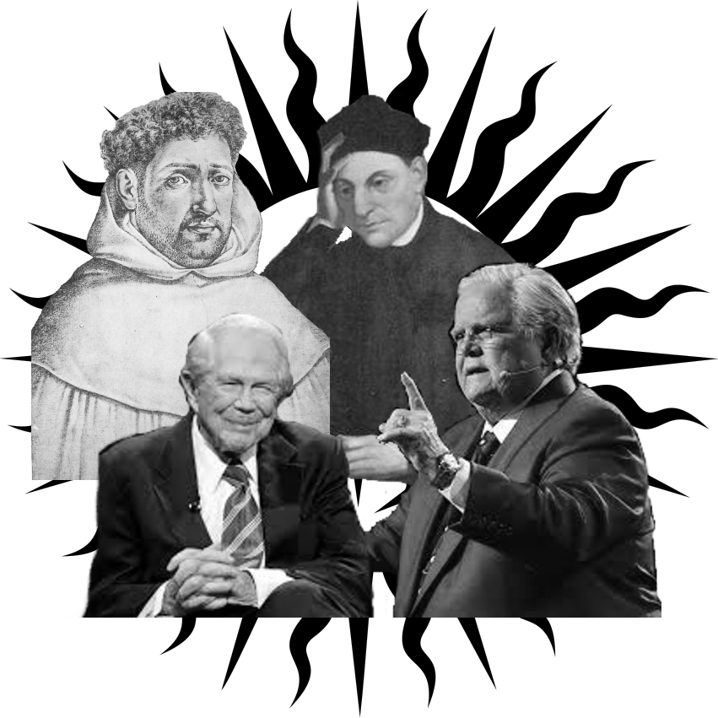

southernprotestant.com

